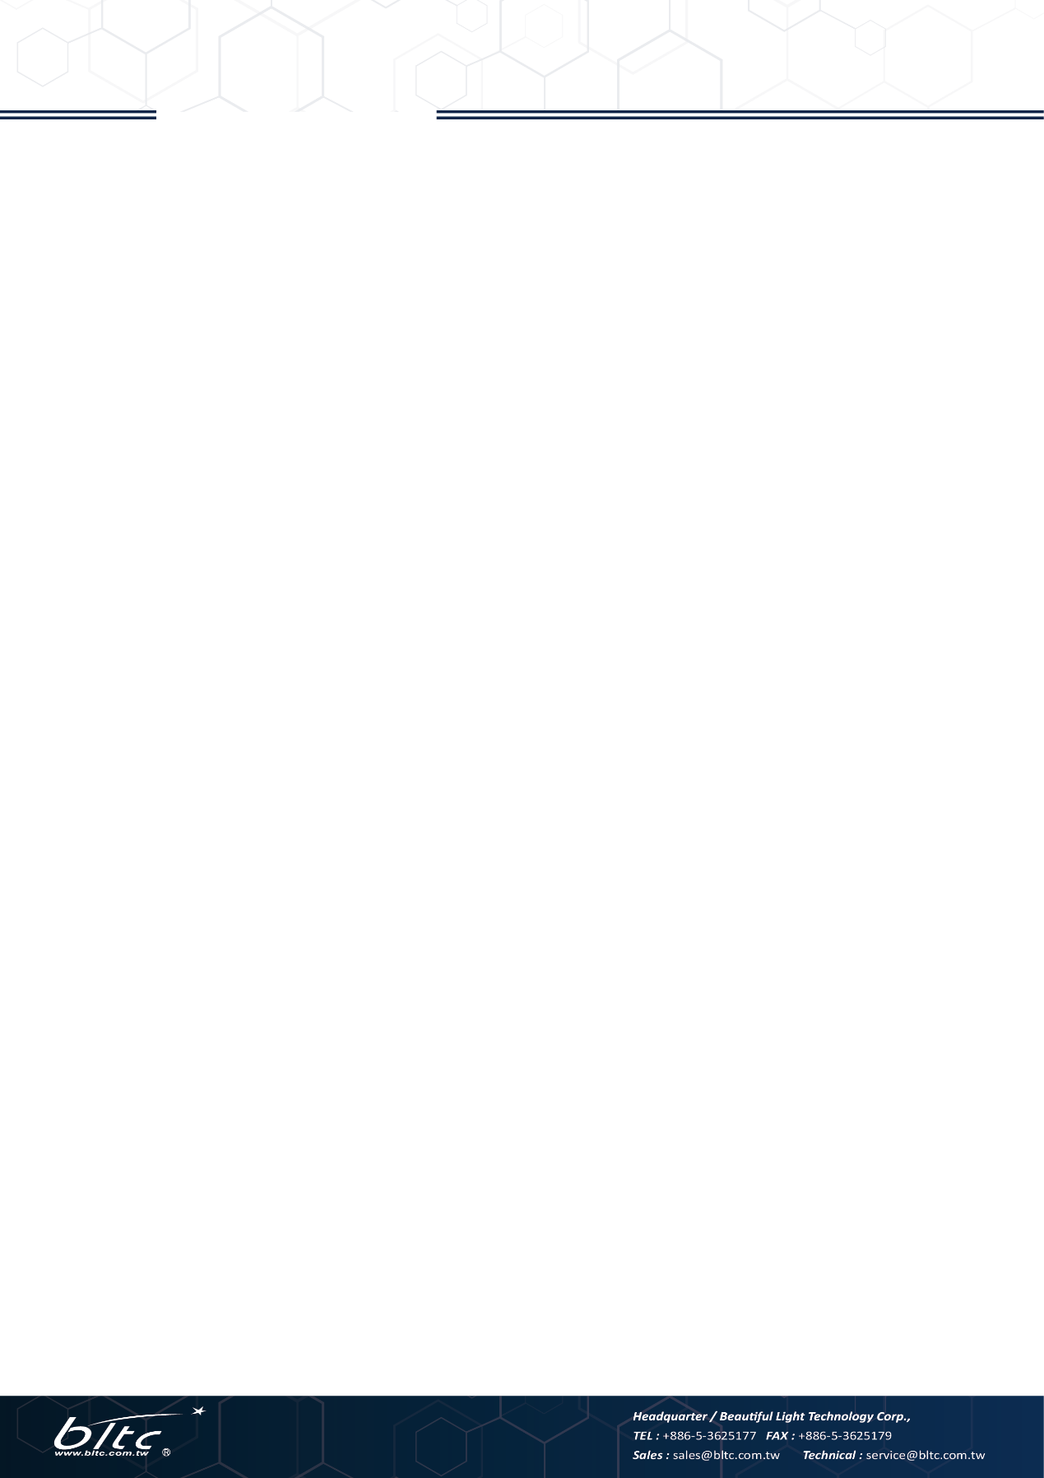

**12W Smart LED Driver 1CH/2CH**

**Feature:**

* Bridge to BLTC smart Lighting system
* 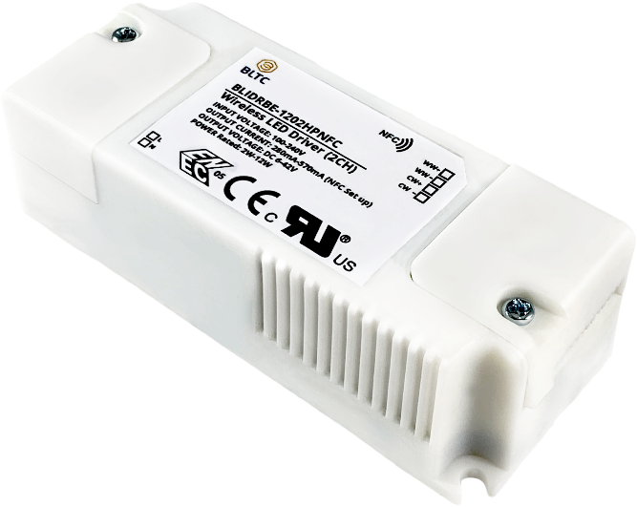Suitable for wide range working voltage
* Constant power output
* NFC output adjustment

**Product Number:**

BLIDRBE-1201HPNFC

BLIDRBE-1202HPNFC

BLIDRBE-1201HPNFCEXT

BLIDRBE-1202HPNFCEXT

*Contact our sales for more details

**Certification:**

**Specification**

**Intelligent**

|  |  |  |  |
| --- | --- | --- | --- |
| Input | | Output | |
| Input Voltage | 100-277V | Working Voltage | 6-42V |
| Inrush current | 20A@230V | Full load Voltage | 21-42V |
| Power Factor | >0.9@full load | Working Current | 280-570 mA |
| Frequency | 47-63 Hz | Output Power Rated | 12W |
| Leakage Current | <0.5mA@240V | Efficiency | >80%@full load |
| Dimming & Color Tuning Level | | | |
| Dimming Level | | 0-100% | |
| Color Tuning Level | | 100 intervals in CCT range | |
| Dimension | | | |
| Dimension | 85*35*25.5 mm | Net Weight |  |
| Packing Volume |  | Gross Weight |  |
| Environment | | | |
| Working Temperature (Tcase) | | -30~+80°C | |
| Storage Temperature | | -40~+70°C | |
| Accessory | | | |
| External Antenna (optional) | | | |

**Wiring Diagram**

**1CH Driver**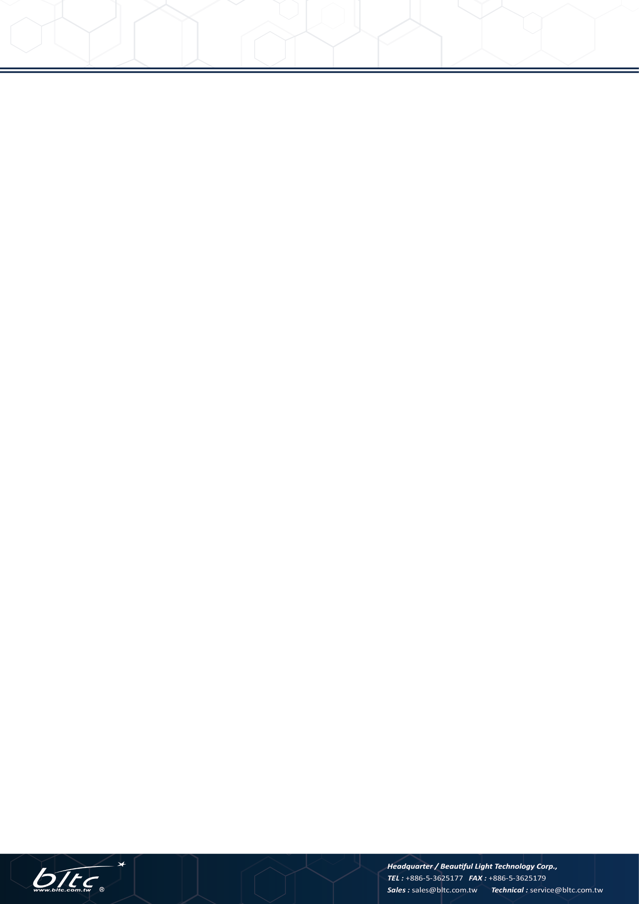

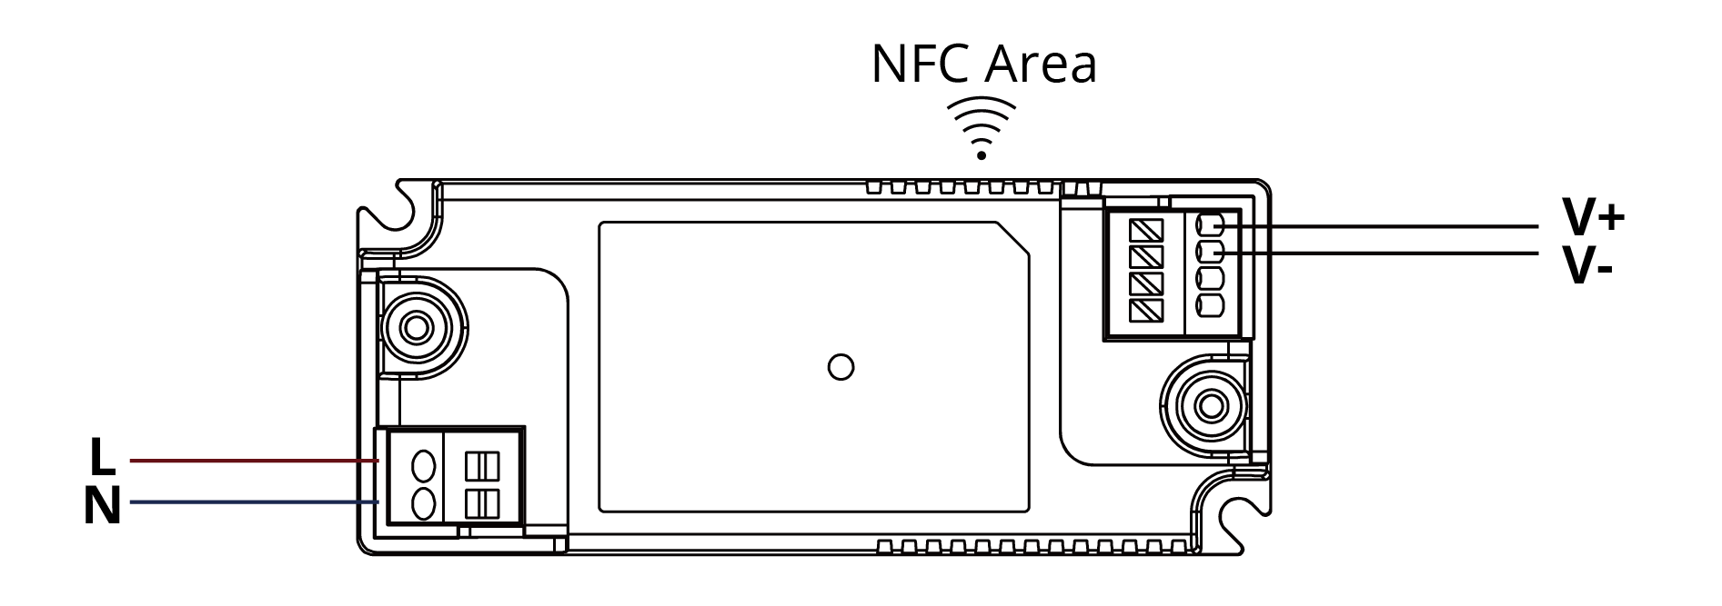

**2CH Driver**

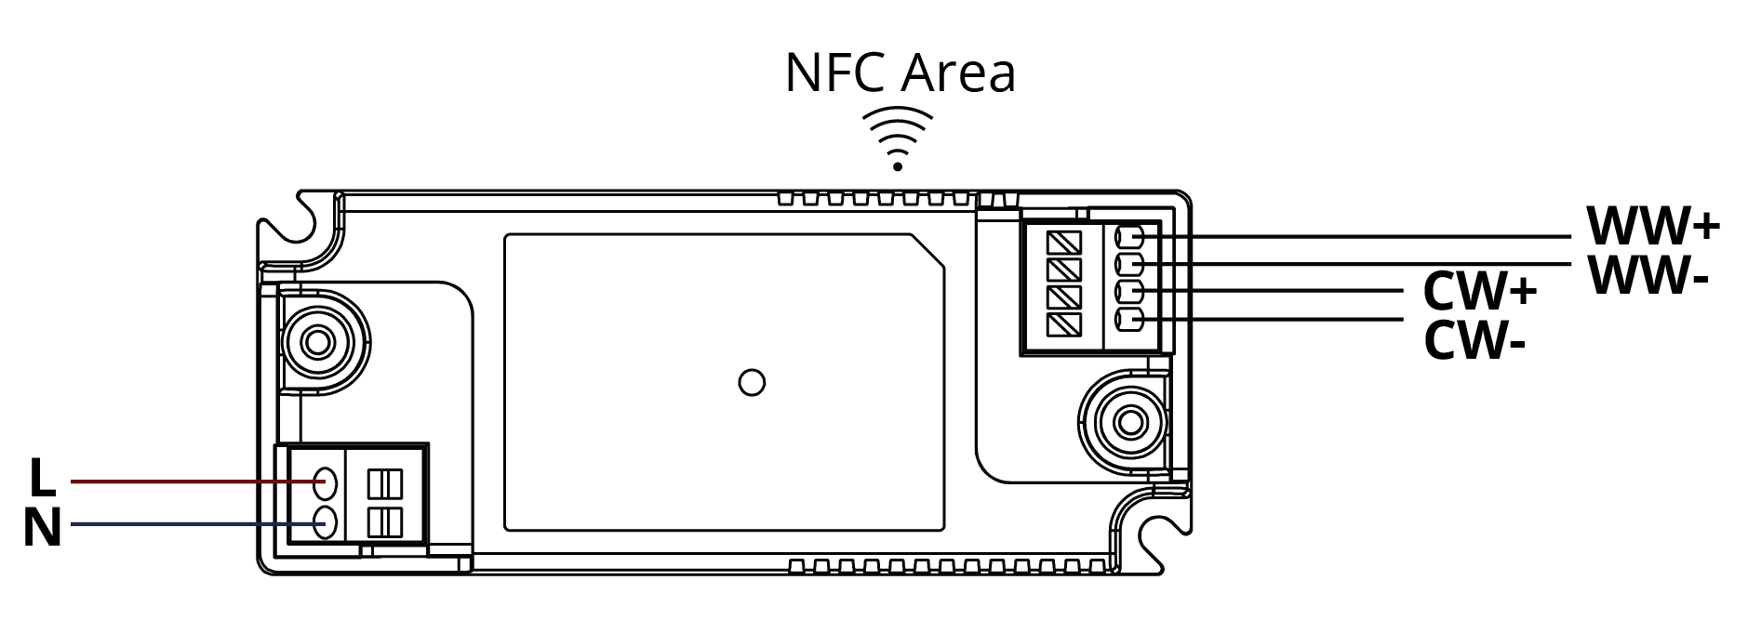

Note**:**

* Pay attention to the connection with LED board, especially for 2CH LED board.

* WW+/WW- should connect to lower CCT input; and CW+/CW- to higher CCT input.

**Installation Procedure**

1. Please turn off the power supply before installation.
2. Loosen the screw and take out of the cover outside of connector.

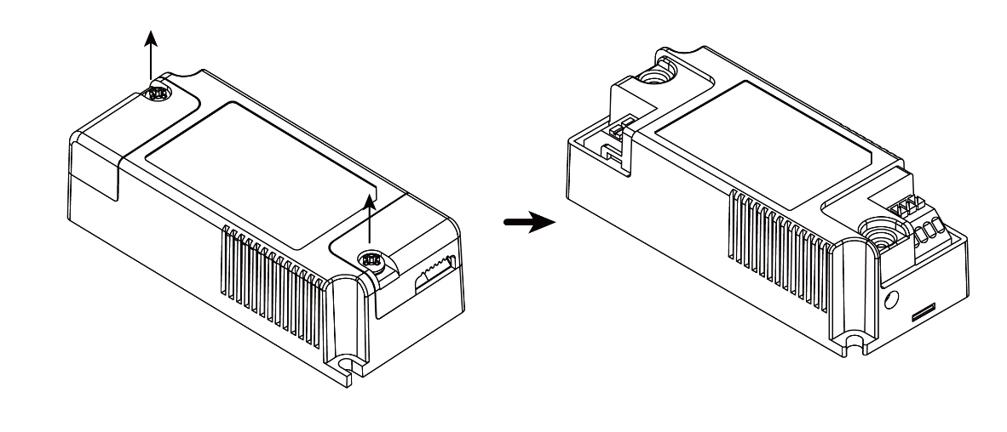

1. Connect the cable following the wiring diagram.
2. The driver will detect the input voltage of LED board and automatically setup the output current to reach the max power output. Please refer to the following table:

Table 1. Relation between output current and working voltage

|  |  |  |
| --- | --- | --- |
| LED Board Input Voltage | Driver Output Current | Output Power |
| 42V | 285mA | 12W |
| 36V | 333mA | 12W |
| 30V | 400mA | 12W |
| 27V | 444mA | 12W |
| 21V | 570mA | 12W |
| 15V | 570mA | 8.55W |
| 12V | 570mA | 6.84W |
| 6V | 570mA | 3.42W |



1. If the output power is too large for your LED board, you can adjust it by the NFC. Please refer to the operation of NFC output setting:
   * Make sure you have a mobile device with Android based OS and NFC function is on.
   * Download “NLM-PWM Demo.apk” and install on your device.
   * Turn on your device, and click the icon to open the software.

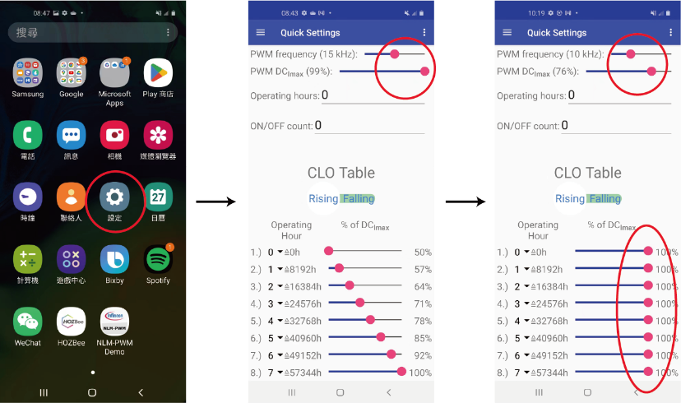

* + Now it’s okay to adjust the output. The output ratio is from 0%-99%. Referring to Table 1, you can set up the ratio of the exact power that the LED board needs. For example, if the LED board wattage is 10W, you can set the ratio to 10/12= 83%.
  + Please set up frequency to 10KHz and the DCImax 100% as above shows.
  + Put your device near the NFC area shown in the wiring diagram with distance less than 2 cm. The device will then transmit the setting to the driver.

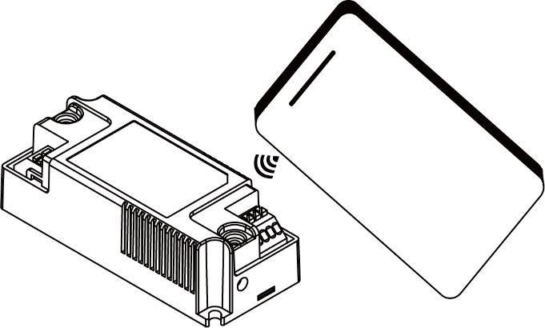

* + Put the cover back and provide power supply to finish the installation.



**APP Setup**

BLTC Smart LED Driver is paired and controlled by BLTC’s APP: HOZBEE and FIREBEE. The APP can be downloaded from Google Play or APP Store or scan the following QR Code:

HOZBEE

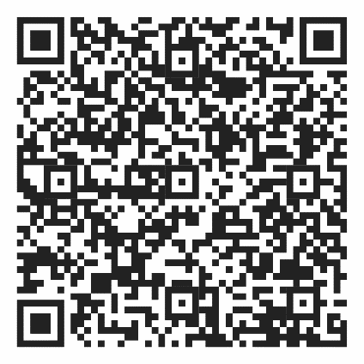

FIREBEE

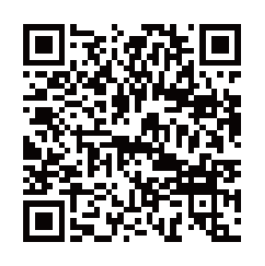

Please check our website for more information about how to operate the APP, or download the user manual from below website:

<https://www.bltc.com.tw/download/download-user%20manual>